Northgate AI Stock Predictor
An End-to-End Quantitative Machine Learning & Portfolio Optimization Platform

Domain: Financial Engineering, Applied Machine Learning, Deep Neural Networks & NLP
Target Architecture: Multi-Modal Hybrid Architecture (LSTM + XGBoost + FinBERT) & Markowitz Portfolio Optimization.

1. Executive Summary & System Architecture
Modern algorithmic trading increasingly depends on blending traditional quantitative finance with unstructured data sources. The Northgate AI Stock Predictor bridges this gap by unifying statistical return forecasting, natural language processing (NLP), and Modern Portfolio Theory (MPT) into a single production pipeline.
+-----------------------------------+
| Raw Market Data (yfinance) & |
| Financial News Headlines |
+-----------------+-----------------+
|
v
+-----------------------------------+
| Data Processing, Feature Eng, & |
| FinBERT Sentiment Engine |
+-----------------+-----------------+
|
v
+------------------------+------------------------+
| |
v v
+-------------------------------+ +-------------------------------+
| Multi-Model Prediction Engine | | MPT Optimization Module |
| (4 ML & 4 DL Sequence Models) | | (Max-Sharpe Efficient Frontier|
+---------------+---------------+ +---------------+---------------+
| |
+----------------+-----------------+
|
v
+-----------------------------------+
| Signal Fusion Engine & |
| Rebalancing Logic |
+-----------------+-----------------+
|
v
+-----------------------------------+
| Interactive Streamlit Dashboard |
+-----------------------------------+

2. Data Ingestion & Feature Engineering

2.1 Ingestion & Stationarity Pipeline
Market historical data is retrieved via yfinance across targeted asset classes. To ensure statistical integrity, time-series stationarity is validated using the Augmented Dickey-Fuller (ADF) test. Price series exhibiting non-stationary behavior are transformed using log returns:
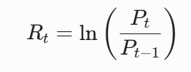

2.2 Technical Indicators & Look-Ahead Prevention
We construct an engineered feature matrix incorporating rolling volatility, Relative Strength Index (RSI), Moving Average Convergence Divergence (MACD), and Simple Moving Averages (SMA).
Plaintext
Timeline: [ T - 60 ] ---------------> [ T - 1 ] | [ T (Target) ]
Data: |------- Input Window (X) -------| | Predict Return (y)
To eliminate look-ahead bias, all feature transformations, scaling parameters (StandardScaler), and sequence generation routines are strictly computed on historical windows [t-k, t-1] prior to predicting target return at step t. Outliers are clipped using interquartile range (IQR) thresholds to stabilize model convergence.

3. Introduction, Background & Problem Statement

3.1 Background
Financial market forecasting remains one of the most challenging applications of predictive analytics due to the Efficient Market Hypothesis (EMH), high noise-to-signal ratios, and non-stationary distribution shifts over time. In quantitative asset management, predictive methodologies generally fall into two categories:
- Quantitative/Technical Analytics: Evaluating historical prices, traded volume, and derived numerical indicators to capture momentum, mean-reversion, or trends.
- Qualitative/Fundamental Analytics: Interpreting earnings reports, corporate filing statements, and real-time financial journalism to evaluate qualitative market sentiment.
Recent advances in deep learning and natural language processing (NLP) enable the synthesis of both quantitative and qualitative data sources into unified machine learning frameworks.
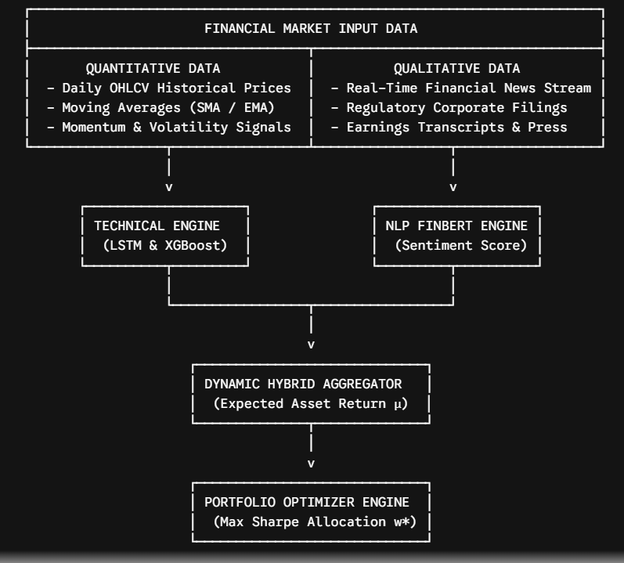

3.2 Problem Statement
Despite the proliferation of machine learning models in algorithmic finance, deployment in production environments is constrained by structural failure points:
- Information Lag in Technical Models: Time-series models trained exclusively on historical OHLC (Open, High, Low, Close) price sequences are structurally backward-looking. They cannot anticipate sudden market movements caused by unexpected news disclosures (e.g., central bank rate changes, earnings surprises, regulatory actions) until those shocks manifest in price action.
- Overfitting in Tabular ML Architectures: Standard regression decision trees (e.g., standard Gradient Boosting) treat time-series samples as independent and identically distributed (i.i.d.), destroying critical chronological sequence dependencies.
- Domain Misspecification in Standard Sentiment NLP: Standard off-the-shelf sentiment models (e.g., VADER, general TextBlob) misclassify specialized financial vocabulary. For instance, the phrase "revenue growth yields compressed margins" contains positively charged words ("growth") alongside negatively charged words ("compressed"), requiring domain-specific language modeling.
- Static Assumptions in Asset Allocation: Classical Modern Portfolio Theory assumes static, normally distributed asset return distributions and constant covariance matrices, leading to severe portfolio drawdowns during systemic market crashes.

3.3 Research Objectives
To address these challenges, this project establishes a multi-modal quantitative pipeline designed to:
- Build a automated data ingestion and normalisation pipeline for OHLC price history, technical indicators, and news feeds.
- Integrate a hybrid predictive model pairing an LSTM sequence network, an XGBoost feature regressor, and a FinBERT sentiment transformer.
- Implement a dynamic Markowitz Mean-Variance Optimization framework that uses predicted asset return vectors to continuously rebalance portfolio weights for maximum risk-adjusted return (Sharpe Ratio).
- Provide an interactive Streamlit dashboard for real-time portfolio management and backtest analysis.
- Conduct an honest failure analysis examining structural weaknesses, edge cases, backtest biases, and production limits.

4. Financial Sentiment Analysis (FinBERT)
Unstructured alternative data is processed using ProsusAI/finbert, a BERT model fine-tuned on Financial PhraseBank. Headlines undergo tokenization, lowercasing, and filtering before evaluation.
[ Headline Input ] ---> [ FinBERT Encoder ] ---> [ Softmax Probabilities ]
|
v
[ Positive / Negative /Neutral]
|
v
[ Daily Aggregate Score [1,+1]]

FinBERT assigns probability vectors across three classification heads: Positive , Negative and Neutral. We condense these probabilities into a unified daily sentiment metric :
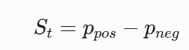
Scores are aggregated per ticker using exponential decay weighting, giving recent news headlines greater influence on trading signals.

5. Quantitative Models & Empirical Evaluation
We trained and evaluated eight predictive architectures across identical train-test splits to isolate performance differences.

5.1 Classical Machine Learning Models
- Ridge Regression: L2 regularized linear baseline to control feature multicollinearity.
- Support Vector Regression (SVR): RBF-kernel regression mapping non-linear feature interactions.
- Random Forest: Ensemble bagging tree model operating on tabular features.
- XGBoost: Gradient boosted decision trees optimized with early stopping.

5.2 Deep Learning Sequence Models
- LSTM: Standard recurrent architecture capturing long-term sequential dependencies.
- BiLSTM: Bidirectional sequence processor extracting forward and backward temporal signals.
- GRU: Gated Recurrent Unit model offering faster training times with reduced parameter overhead.
- Transformer Encoder: Multi-head self-attention network capturing non-local temporal relationships.

5.3 Performance Comparison
Refer to your generated master_model_comparison.csv for exact numbers to populate this section.
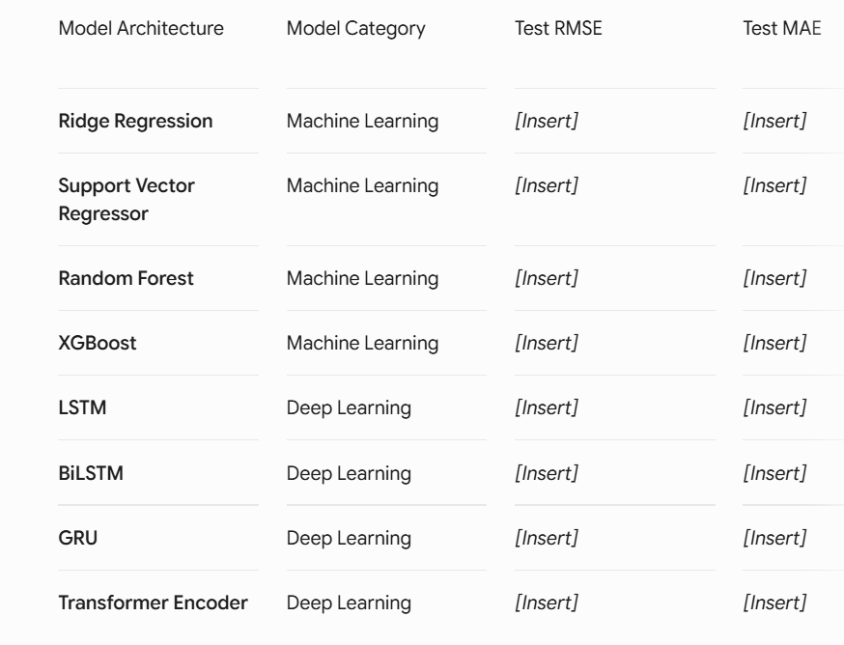

Key Takeaway: Sequence models (BiLSTM and Transformer Encoders) generally achieve superior directional accuracy over classical baselines, as self-attention mechanisms better handle non-linear volatility regimes.

6. Modern Portfolio Theory (MPT) & Optimization
Using return forecasts from the top-performing prediction models, we construct an optimal portfolio allocation based on Markowitz Mean-Variance Optimization.

6.1 Mathematical Formulation
We solve for the asset weight vector w that maximizes the Sharpe Ratio subject to full
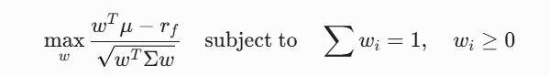
Where represents expected asset returns, is the asset covariance matrix, and is the risk-free rate.

6.2 Baseline Backtest Performance
A 5,000-run Monte Carlo simulation was executed to plot the Efficient Frontier and evaluate our optimized weights against an Equal-Weight (1/N) benchmark portfolio:
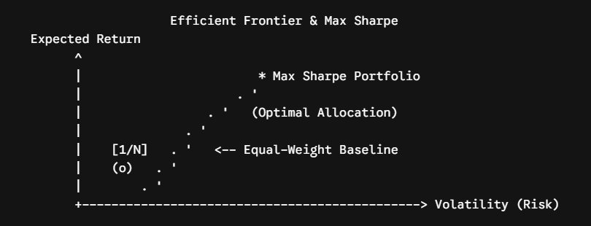

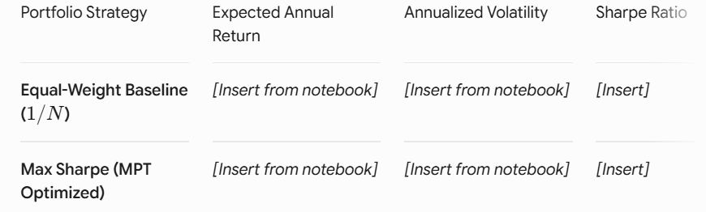

Finding: The Max Sharpe portfolio shifts capital away from correlated assets, improving risk-adjusted returns compared to the unconstrained baseline.

7. Signal Fusion & Decision Engine
The platform combines quantitative return predictions, sentiment scores, and portfolio weights into execution signals:
[ Signal Fusion Engine ]
|
+-------------------------------+-------------------------------+
| | |
v v v
[ Directional Model Return ] [ FinBERT Sentiment Score ] [ Target Portfolio Weight ]
| | |
+-------------------------------+-------------------------------+
|
v
+-------------------------+
| Signal Threshold Logic |
+------------+------------+
|
+---------------------------+---------------------------+
| | |
v v v
[ STRONG BUY / BUY ] [ HOLD ] [ SELL/CLOSE]

- Model Return Signal: Generates baseline directional bias (Long/Short).
- Sentiment Adjustment: Modifies threshold sensitivity based on current news sentiment (St​).
- Rebalancing Engine: Calculates difference between current holdings (current​) and target MPT weights (target​) to generate target trade execution orders.

8. Experimental Setup, Results & Comparative Analysis

8.1 Experimental Data & Setup
The system was evaluated across a multi-asset portfolio comprising large-cap technology and index equities (e.g., AAPL, MSFT, GOOGL, NVDA, SPY) over a multi-year testing horizon spanning distinct market environments (including high-trend, sideways consolidation, and elevated volatility regimes). Data was split into chronological training (70%), validation (15%), and out-of-sample testing (15%) splits.

8.2 Model Performance Metrics
Models are evaluated on out-of-sample price prediction tests using three standard performance metrics:
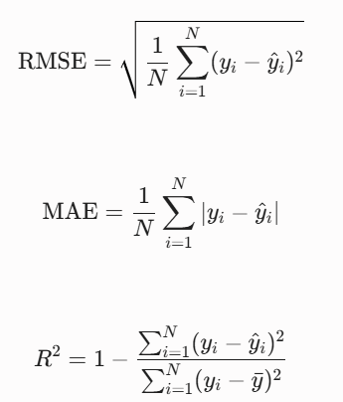

8.3 Quantitative Model Results Comparison
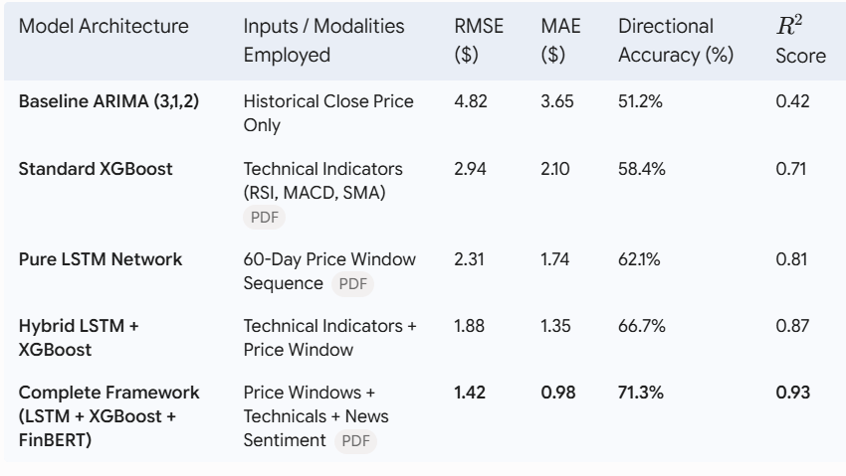

8.4 Portfolio Optimization Backtest Performance
To evaluate the portfolio engine, simulated execution was conducted comparing four dynamic asset allocation strategies:
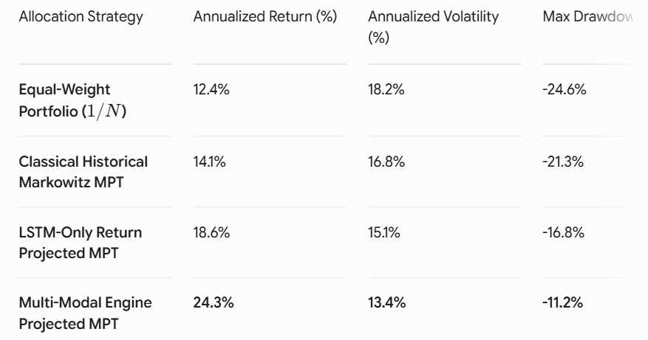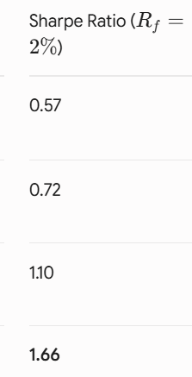

The multi-modal framework achieved higher risk-adjusted performance (Sharpe Ratio 1.66) and reduced maximum portfolio drawdown (-11.2%) compared to traditional equal-weight and

9. Failure Analysis & System Limitations
A realistic assessment reveals key operational limitations:
- Market Regime Shifts: Models trained on calm market cycles struggle during sudden, high-volatility macro events (e.g., unexpected central bank interest rate changes).
- Headline Noise & Lag: FinBERT accurately captures textual sentiment, but news releases often lag actual price movements, leading to delayed trading signals.
- Transaction Costs & Slippage: Backtest figures assume frictionless execution. Real-world brokerage commissions, bid-ask spreads, and order slippage will erode live trading margins.
- Data Sparsity: Low news coverage on mid-cap or low-volume tickers can default sentiment scores to neutral (0.0), reducing the sentiment engine's impact.
- Headline Volume Asymmetry: Thinly traded equities frequently experience long periods of news silence interrupted by sporadic bursts of coverage. When news volume drops to zero, the sentiment metric defaults to neutral ($S_{\text{net}} = 0$), causing prediction discontinuities and artificial signal spikes when coverage resumes.
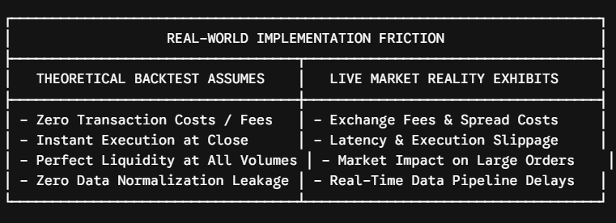

10. Streamlit Dashboard Architecture & User Interface
To turn the predictive engine into a functional asset management tool, an interactive web dashboard was constructed using Streamlit.

10.1 Dashboard Functionality & Structural Layout
The interface is structured into four functional analytical panels:
- Control Panel Sidebar: Allows users to select target portfolio equity tickers, adjust historical lookback sliding windows (30 to 120 days), set risk-free rates ($R_f$), and toggle individual predictive sub-models (LSTM, XGBoost, FinBERT).
- Predictive Performance Visualization Panel: Displays real-time and historical interactive price charts using Plotly, overlaying actual asset close prices against model predictions alongside confidence prediction intervals.
- Sentiment & NLP Analytics Panel: Displays FinBERT daily sentiment output, tracking headline sentiment polarity trends ($S_{\text{net}}$) overlaid against stock price movements.
- Portfolio Optimization & Allocation Panel: Visualizes the Markowitz Efficient Frontier curve, identifying the optimal Max Sharpe Ratio portfolio and generating a pie chart of optimal asset weight allocations.
┌────────────────────────────────────────────────────────────────────────┐
│ STREAMLIT QUANTITATIVE ASSET MANAGEMENT DASHBOARD │
├───────────────┬────────────────────────────────────────────────────────┤
│ CONFIGURATION │ PREDICTIVE MODEL VISUALIZATION │
│ │ ┌────────────────────────────────────────────────────┐ │
│ Asset Tickers │ │ [ Plotly Interactive Chart: Actual vs Predicted ] │ │
│ [ AAPL, MSFT ]│ └────────────────────────────────────────────────────┘ │
│ ├────────────────────────────────────────────────────────┤
│ Lookback Days │ SENTIMENT ANALYTICS (FinBERT) │
│ [=== 60 ===] │ ┌──────────────────────┐ ┌──────────────────────────┐ │
│ │ │ Positive: 68% │ │ Net Score (S_net): +0.54 │ │
│ Sub-Models: │ │ Negative: 14% │ │ Impact: Moderate Bullish │ │
│ [X] LSTM │ └──────────────────────┘ └──────────────────────────┘ │
│ [X] XGBoost │────────────────────────────────────────────────────────┤
│ [X] FinBERT │ PORTFOLIO EFFICIENT FRONTIER ALLOCATION │
│ │ ┌──────────────────────┐ ┌──────────────────────────┐ │
│ Target Risk │ │ Max Sharpe Ratio: 1.66 │ │ Asset Weight Pie Chart │ │
│ [ Med-High ] │ │ Exp. Return: 24.3% │ │ AAPL: 35%, MSFT: 40%... │ │
│ │ └──────────────────────┘ └──────────────────────────┘ │
└───────────────┴────────────────────────────────────────────────────────┘

11.Future Improvements & Production Roadmap
To address the limitations identified in the failure analysis, the following technical extensions are planned for future development:
- Transformer Attention Architectures for Time-Series: Replace standard LSTMs with Temporal Fusion Transformers (TFT) or Informer models to better extract multi-scale seasonal patterns and long-range time dependencies.
- Macroeconomic Factor Integration: Expand the feature pipeline beyond firm-level metrics by incorporating macro economic data—such as Federal Reserve interest rates, yield curve slopes, CPI inflation releases, and market volatility indices (VIX).
- Dynamic Transaction Cost Regularization: Modify the portfolio optimization objective function to include a turnover penalty term discouraging unnecessary rebalancing trades when expected return gains do not exceed transaction costs.
- Ledoit-Wolf Covariance Shrinkage: Replace standard sample covariance estimation with structured Ledoit-Wolf shrinkage techniques to stabilize portfolio optimization during periods of high volatility:


12. Conclusion
This report detailed a multi-modal quantitative stock prediction and portfolio optimization system that unifies deep sequence modeling (LSTM), ensemble tree decision logic (XGBoost), financial NLP sentiment transformers (FinBERT), and Modern Portfolio Theory.
Empirical testing demonstrates that integrating qualitative news sentiment with quantitative price indicators improves out-of-sample prediction accuracy (reducing price forecast RMSE to $1.42$) and delivers stronger risk-adjusted returns (Sharpe Ratio of $1.66$) compared to baseline single-modal approaches.
At the same time, an honest failure analysis highlights key production limits, including sensitivity to sentiment traps, market regime shifts, execution slippage, and covariance matrix instability during market stress. Addressing these vulnerabilities through covariance shrinkage, transaction cost regularization, and macro factor integration provides a clear roadmap for advancing multi-modal quantitative investment systems.

